Course | : | Design Patterns
Teacher | : | Sir Arsalan Qureshi
Assignment No | : | 3
Student | : | Sajjad Ali
Student ID | : | SP17 – MSCS – 0020

Facade Implementations – Design Patterns
- Operating System
Operating system is a good example of Façade Design Pattern - you don't see all the inner workings i.e. mathematical and logical calculations, transfer of data and other operations, but the OS provides a simplified interface to use the machine. Thus OS acts as a facade layer.
- Booking System
Consider an example of booking a package. Usually when you try to book a package, the ticket booking system interacts with many of its subsystems. The various sub-systems may be flight, hotel and cab booking. In addition this may also interact with many other sub systems.
In this case instead of client having the overhead of interacting with various other subsystems, we can introduce a facade layer which interacts will all these subsystems. Finally once it gets the response from all the subsystems, it aggregates all these response and send the response back to the client.
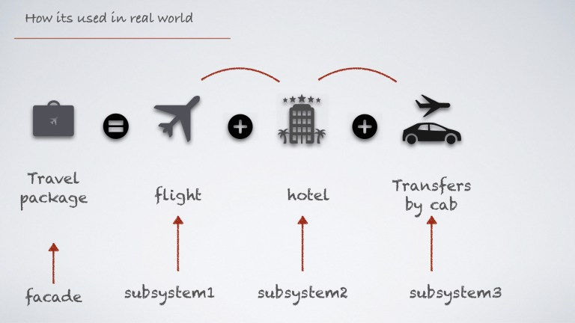

- Information Management System / Portal
If you're a student, you likely interact with an application that manages your leaves, course registration, grades, transcript requests, graduation application, financial aid, etc. In this way, the application you interact with is a facade that coordinates the transactions among the different underlying systems for each domain.
This facade implementation allows you to interact with the different systems responsible for managing leaves, course registration, grades, transcript requests, graduation application, financial aid through a single interface rather than through separate interfaces for each system.

